Name-Priyanka Tyagi

Sec-B

Roll No-1900290149074

* Write a program to implement Bresenhams Line Drawing Algorithm.

**Bresenham's line algorithm** is a [line drawing algorithm](https://en.wikipedia.org/wiki/Line_drawing_algorithm) that determines the points of an *n*-dimensional [raster](https://en.wikipedia.org/wiki/Raster_graphics) that should be selected in order to form a close approximation to a [straight line between two points](https://en.wikipedia.org/wiki/Straight_line_between_two_points).

This algorithm is used for scan converting a line. It was developed by Bresenham. It is an efficient method because it involves only integer addition, subtractions, and multiplication operations. These operations can be performed very rapidly so lines can be generated quickly.

In this method, next pixel selected is that one who has the least distance from true line.

The method works as follows:

Assume a pixel P1'(x1',y1'),then select subsequent pixels as we work our may to the night, one pixel position at a time in the horizontal direction toward P2'(x2',y2').

Once a pixel in choose at any step

The next pixel is

1. Either the one to its right (lower-bound for the line)
2. One top its right and up (upper-bound for the line)

The line is best approximated by those pixels that fall the least distance from the path between P1',P2'.

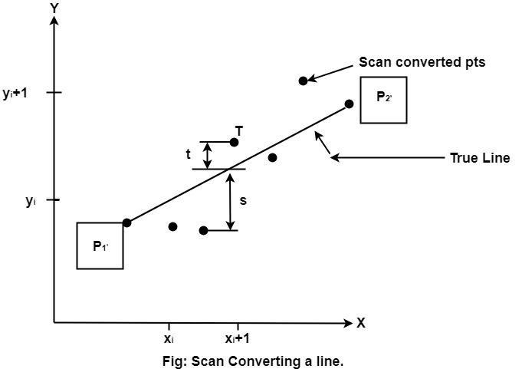

To chooses the next one between the bottom pixel S and top pixel T.  
            If S is chosen  
            We have xi+1=xi+1       and       yi+1=yi  
            If T is chosen  
            We have xi+1=xi+1       and       yi+1=yi+1

The actual y coordinates of the line at x = xi+1is  
            y=mxi+1+b

1ping.png

The distance from S to the actual line in y direction  
            s = y-yi

The distance from T to the actual line in y direction  
            t = (yi+1)-y

Now consider the difference between these 2 distance values  
            s - t

When (s-t) <0 ⟹ s < t

The closest pixel is S

When (s-t) ≥0 ⟹ s < t

The closest pixel is T

This difference is  
            s-t = (y-yi)-[(yi+1)-y]  
                    = 2y - 2yi -1

2ping.png

Substituting m by  and introducing decision variable  
                di=△x (s-t)  
                di=△x (2  (xi+1)+2b-2yi-1)  
                        =2△xyi-2△y-1△x.2b-2yi△x-△x  
                di=2△y.xi-2△x.yi+c

Where c= 2△y+△x (2b-1)

We can write the decision variable di+1 for the next slip on  
                di+1=2△y.xi+1-2△x.yi+1+c  
                di+1-di=2△y.(xi+1-xi)- 2△x(yi+1-yi)

Since x_(i+1)=xi+1,we have  
                di+1+di=2△y.(xi+1-xi)- 2△x(yi+1-yi)

Special Cases

If chosen pixel is at the top pixel T (i.e., di≥0)⟹ yi+1=yi+1  
                di+1=di+2△y-2△x

If chosen pixel is at the bottom pixel T (i.e., di<0)⟹ yi+1=yi  
                di+1=di+2△y

Finally, we calculate d1  
                d1=△x[2m(x1+1)+2b-2y1-1]  
                d1=△x[2(mx1+b-y1)+2m-1]

Since mx1+b-yi=0 and m = , we have

                d1=2△y-△x

**Algorithm:-**

**Step1:** Start Algorithm

**Step2:** Declare variable x1,x2,y1,y2,d,i1,i2,dx,dy

**Step3:** Enter value of x1,y1,x2,y2  
                Where x1,y1are coordinates of starting point  
                And x2,y2 are coordinates of Ending point

**Step4:** Calculate dx = x2-x1  
                Calculate dy = y2-y1  
                Calculate i1=2*dy  
                Calculate i2=2*(dy-dx)  
                Calculate d=i1-dx

**Step5:** Consider (x, y) as starting point and xendas maximum possible value of x.  
                If dx < 0  
                        Then x = x2  
                        y = y2  
                          xend=x1  
                If dx > 0  
                    Then x = x1  
                y = y1  
                        xend=x2

**Step6:** Generate point at (x,y)coordinates.

**Step7:** Check if whole line is generated.  
                If x > = xend  
                Stop.

**Step8:** Calculate co-ordinates of the next pixel  
                If d < 0  
                    Then d = d + i1  
                If d ≥ 0  
          Then d = d + i2  
                Increment y = y + 1

**Step9:** Increment x = x + 1

**Step10:** Draw a point of latest (x, y) coordinates

**Step11:** Go to step 7

**Step12:** End of Algorithm

**Program:-**

1. #include<stdio.h>
2. #include<graphics.h>
3. **void** drawline(**int** x0, **int** y0, **int** x1, **int** y1)
4. {
5. **int** dx, dy, p, x, y;
6. dx=x1-x0;
7. dy=y1-y0;
8. x=x0;
9. y=y0;
10. p=2*dy-dx;
11. **while**(x<x1)
12. {
13. **if**(p>=0)
14. {
15. putpixel(x,y,7);
16. y=y+1;
17. p=p+2*dy-2*dx;
18. }
19. **else**
20. {
21. putpixel(x,y,7);
22. p=p+2*dy;}
23. x=x+1;
24. }
25. }
26. **int** main()
27. {
28. **int** gdriver=DETECT, gmode, error, x0, y0, x1, y1;
29. initgraph(&gdriver, &gmode, "c:\\turboc3\\bgi");
30. printf("Enter co-ordinates of first point: ");
31. scanf("%d%d", &x0, &y0);
32. printf("Enter co-ordinates of second point: ");
33. scanf("%d%d", &x1, &y1);
34. drawline(x0, y0, x1, y1);
35. **return** 0;
36. }

**O/P**

